Trinity Church

Seventh Sunday after Pentecost

July 24, 2022

9:30 a.m.

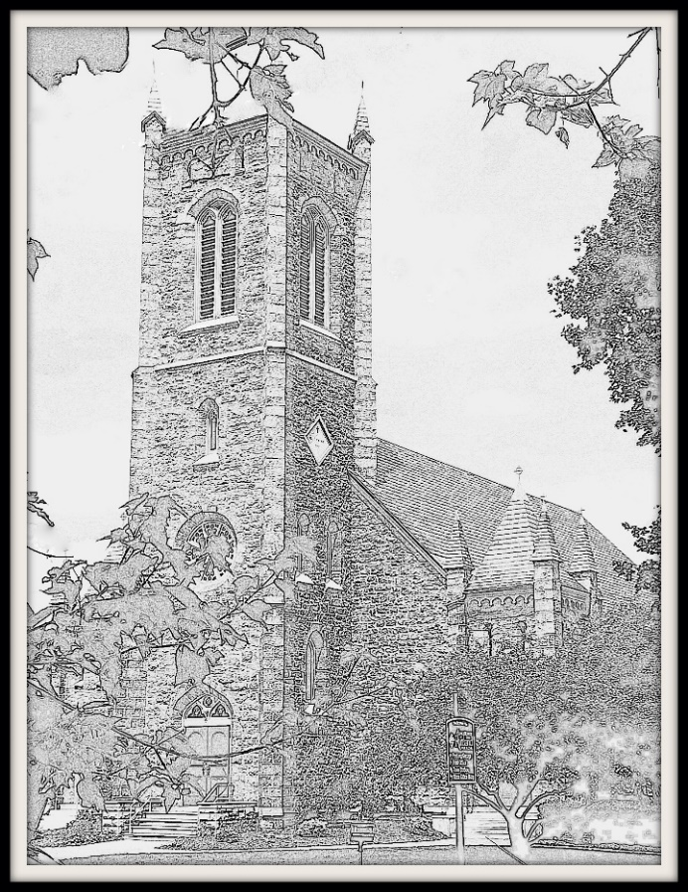

Welcome to our Trinity Church family!

85 West Street, Rutland, VT 05701

(802) 775-4368

office@trinitychurchrutland.org

www.trinitychurchrutland.org

We are a dynamic Episcopal family united in following Christ.

Seeking God Growing in spirituality Serving all with compassion Embracing courageous hope



9:30a.m. Seventh Sunday after Pentecost – Holy Eucharist

The Word of the Lord

**Prelude *Five Kyrie versets (Messe pour les couvents) Francois Couperin***

**Opening Hymn *#388 O worship the King, all-glorious above***

Opening Sentences

Celebrant: Blessed be the one, holy, and living God.

*People: Glory to God for ever and ever.*

Celebrant: Holy Wisdom, in your loving kindness you created and restored us when we were lost: inspire us with your truth, that we may love you with our whole minds and run to you with open hearts, through Christ our Savior. *Amen.*

**Gloria in Excelsis *S 277***

The Collect of the Day

Celebrant: God is with you.

*People: And also with you.*

Celebrant: Let us pray.

O God, the protector of all who trust in you, without whom nothing is strong, nothing is holy: Increase and multiply upon us your mercy; that, with you as our ruler and guide, we may so pass through things temporal, that we lose not the things eternal; through Jesus Christ our Lord, who lives and reigns with you and the Holy Spirit, one God, for ever and ever. *Amen*.

Lessons of the Day

First Reading Genesis 18:20-32

Reader: A reading from the book of Genesis.

The Lord said to Abraham, "How great is the outcry against Sodom and Gomorrah and how very grave their sin! I must go down and see whether they have done altogether according to the outcry that has come to me; and if not, I will know." So the men turned from there, and went toward Sodom, while Abraham remained standing before the Lord. Then Abraham came near and said, "Will you indeed sweep away the righteous with the wicked? Suppose there are fifty righteous within the city; will you then sweep away the place and not forgive it for the fifty righteous who are in it? Far be it from you to do such a thing, to slay the righteous with the wicked, so that the righteous fare as the wicked! Far be that from you! Shall not the Judge of all the earth do what is just?" And the Lord said, "If I find at Sodom fifty righteous in the city, I will forgive the whole place for their sake." Abraham answered, "Let me take it upon myself to speak to the Lord, I who am but dust and ashes. Suppose five of the fifty righteous are lacking? Will you destroy the whole city for lack of five?" And he said, "I will not destroy it if I find forty-five there." Again he spoke to him, "Suppose forty are found there." He answered, "For the sake of forty I will not do it." Then he said, "Oh do not let the Lord be angry if I speak. Suppose thirty are found there." He answered, "I will not do it, if I find thirty there." He said, "Let me take it upon myself to speak to the Lord. Suppose twenty are found there." He answered, "For the sake of twenty I will not destroy it." Then he said, "Oh do not let the Lord be angry if I speak just once more. Suppose ten are found there." He answered, "For the sake of ten I will not destroy it."

Hear what the Spirit is saying to God’s people.

*People: Thanks be to God.*

Psalm Psalm 138

Priest: Please join me in reciting Psalm 138. The congregation will respond on the italicized verses.

1 I will give thanks to you, O Lord, with my whole heart; *

before the gods I will sing your praise.

*2 I will bow down toward your holy temple and praise your Name, \**

*because of your love and faithfulness;*

3 For you have glorified your Name *

and your word above all things.

*4 When I called, you answered me; \**

*you increased my strength within me.*

5 All the kings of the earth will praise you, O Lord, *

when they have heard the words of your mouth.

*6 They will sing of the ways of the Lord, \**

*that great is the glory of the Lord.*

7 Though the Lord be high, he cares for the lowly; *

he perceives the haughty from afar.

*8 Though I walk in the midst of trouble, you keep me safe; \**

*you stretch forth your hand against the fury of my enemies; your right hand shall save me.*

9 The Lord will make good his purpose for me; *

O Lord, your love endures for ever; do not abandon the works of your hands.

Second Reading Colossians 2:6-19

Reader: A reading from the letter to the Colossians.

As you have received Christ Jesus the Lord, continue to live your lives in him, rooted and built up in him and established in the faith, just as you were taught, abounding in thanksgiving. See to it that no one takes you captive through philosophy and empty deceit, according to human tradition, according to the elemental spirits of the universe, and not according to Christ. For in him the whole fullness of deity dwells bodily, and you have come to fullness in him, who is the head of every ruler and authority. In him also you were circumcised with a spiritual circumcision, by putting off the body of the flesh in the circumcision of Christ; when you were buried with him in baptism, you were also raised with him through faith in the power of God, who raised him from the dead. And when you were dead in trespasses and the uncircumcision of your flesh, God made you alive together with him, when he forgave us all our trespasses, erasing the record that stood against us with its legal demands. He set this aside, nailing it to the cross. He disarmed the rulers and authorities and made a public example of them, triumphing over them in it. Therefore do not let anyone condemn you in matters of food and drink or of observing festivals, new moons, or sabbaths. These are only a shadow of what is to come, but the substance belongs to Christ. Do not let anyone disqualify you, insisting on self-abasement and worship of angels, dwelling on visions, puffed up without cause by a human way of thinking, and not holding fast to the head, from whom the whole body, nourished and held together by its ligaments and sinews, grows with a growth that is from God.

Hear what the Spirit is saying to God’s people.

*People: Thanks be to God.*

**Sequence Hymn *#615 "Thy kingdom come", on bended knee***

Gospel Luke 11:1-13

Celebrant: The Holy Gospel of our Savior Jesus Christ according to Luke.

*People: Glory to you, O Christ.*

Celebrant: Jesus was praying in a certain place, and after he had finished, one of his disciples said to him, "Lord, teach us to pray, as John taught his disciples." He said to them, "When you pray, say: Father, hallowed be your name. Your kingdom come. Give us each day our daily bread. And forgive us our sins, for we ourselves forgive everyone indebted to us. And do not bring us to the time of trial." And he said to them, "Suppose one of you has a friend, and you go to him at midnight and say to him, `Friend, lend me three loaves of bread; for a friend of mine has arrived, and I have nothing to set before him.' And he answers from within, `Do not bother me; the door has already been locked, and my children are with me in bed; I cannot get up and give you anything.' I tell you, even though he will not get up and give him anything because he is his friend, at least because of his persistence he will get up and give him whatever he needs. "So I say to you, Ask, and it will be given you; search, and you will find; knock, and the door will be opened for you. For everyone who asks receives, and everyone who searches finds, and for everyone who knocks, the door will be opened. Is there anyone among you who, if your child asks for a fish, will give a snake instead of a fish? Or if the child asks for an egg, will give a scorpion? If you then, who are evil, know how to give good gifts to your children, how much more will the heavenly Father give the Holy Spirit to those who ask him!"

The Gospel of Christ.

*People: Praise to you, O Christ.*

Sermon The Rev. Sarah Ginolfi

The Nicene Creed (Congregation)

Officiant: Please join me in saying the Nicene Creed.

*People: We believe in one God, the Father, the Almighty, maker of heaven and earth, of all that is, seen and unseen.*

*We believe in one Lord, Jesus Christ, the only Son of God, eternally begotten of the Father, God from God, Light from Light, true God from true God, begotten, not made, of one Being with the Father. Through him all things were made. For us and for our salvation he came down from heaven: by the power of the Holy Spirit he became incarnate from the Virgin Mary, and was made man. For our sake he was crucified under Pontius Pilate; he suffered death and was buried. On the third day he rose again in accordance with the Scriptures; he ascended into heaven and is seated at the right hand of the Father. He will come again in glory to judge the living and the dead, and his kingdom will have no end.*

*We believe in the Holy Spirit, the Lord, the giver of life, who proceeds from the Father and the Son. With the Father and the Son he is worshiped and glorified. He has spoken through the Prophets. We believe in one holy catholic and apostolic Church. We acknowledge one baptism for the forgiveness of sins. We look for the resurrection of the dead, and the life of the world to come. Amen.*

Intercession Prayers

Reader: Dear God, we seek to follow your will. Guide us as we grow in spirituality, serve all with compassion, and embrace your courageous hope in the world. With all our heart and with all our mind, let us pray to God, saying "God, have mercy."

*Silence.*

Reader: For the peace promised to us by Jesus Christ, for the loving-kindness of God, and for the salvation of our souls, let us pray to God.

*People: God, have mercy.*

Reader: For the peace of the world, for the welfare of the Holy Church of God, and for the unity of all peoples; for **The Episcopal Church; St. Luke's Church, St. Albans; Emily O’Connor, Senior Warden, Deacon Jim Ballard**, let us pray to God.

*People: God, have mercy.*

Reader: For Justin, Archbishop of Canterbury, Michael, our Presiding Bishop, Shannon, our Bishop; and Sarah, our priest, for all bishops and other ministers;

*People: God, have mercy.*

Reader: For our President, for the leaders of the nations, and for all in authority, let us pray to God.

*People: God, have mercy.*

Reader: For the County of Rutland, this city, and for every city and community, and for those who live in them, let us pray to God.

*People: God, have mercy.*

Reader: For seasonable weather, and for an abundance of the fruits of the earth; for this good earth which God has given us, and the wisdom and will to conserve it, let us pray to God.

*People: God, have mercy.*

Reader: For those who travel on land, on water, or in the air, let us pray to God.

*People: God, have mercy.*

Reader: For the aged and infirm, for the widowed and orphans, for the sick and the suffering, and for those commended to our prayers, especially **Samuel & Eli, Nanci, JoAnn & Larry, Jamie, Jerry, Alaine, Patricia**, let us pray to God.

*People: God, have mercy.*

Reader: For the poor and the oppressed, for the unemployed and the destitute, for prisoners and captives, and for all who remember and care for them, let us pray to God.

*People: God, have mercy.*

Reader: For all who have died in the hope of the resurrection, **especially Maureen Schillinger who died last week,** and for all the departed, let us pray to God.

*People: God, have mercy.*

Reader: For deliverance from all danger, violence, oppression, and degradation, let us pray to God.

*People: God, have mercy.*

Reader: That we may end our lives in faith and hope, without suffering and without reproach, let us pray to God.

*People: God, have mercy.*

Reader: For this congregation, let us pray for those celebrating birthdays and anniversaries this week, especially **Bradley Maniery, Sam Hall, Krey Kellington, Bruce Howard, Amy Lynch, David Phillips, Deborah Rampone**. **We also celebrate Elizabeth Bushey, for whom the altar flowers have been given, and wish her well on her move and in her continuing education.** Let us commend ourselves, and one another, and all our life, to Christ our God.

*People: To you, O Lord, our God.*

Celebrant: O God, you made us in your own image and redeemed us through Jesus your Son: Look with compassion on the whole human family; take away the arrogance and hatred which infect our hearts; break down the walls that separate us; unite us in bonds of love; and work through our struggle and confusion to accomplish your purposes on earth; that, in your good time, all nations and races may serve you in harmony around your heavenly throne; through Jesus Christ our Lord. *Amen*.

The Confession and Absolution

Celebrant: Let us confess our sins against God and our neighbor.

*All: Most merciful God, we confess that we have sinned against you in thought, word, and deed, by what we have done, and by what we have left undone. We have not loved you with our whole heart; we have not loved our neighbors as ourselves. We are truly sorry and we humbly repent. For the sake of your Son Jesus Christ, have mercy on us and forgive us; that we may delight in your will, and walk in your ways, to the glory of your Name. Amen.*

Celebrant: Almighty God have mercy on you, forgive you all your sins through our Lord Jesus Christ, strengthen you in all goodness, and by the power of the Holy Spirit keep you in eternal life. *Amen*.

The Peace

Officiant: The peace of Christ be always with you.

*People: And also with you.*

Announcements

*Thank you for your financial commitment to the life of Trinity Church. Your gift helps our church family spread God’s love and joy in the world! (To ensure you receive a giving statement, please ask for offering envelopes or write your name on a plain envelope containing your gift.) Offering plates are located at the top of the center aisle near the altar as well as near the center exit doors.*

The Holy Communion *Enriching Our Worship, Eucharistic Prayer 2*

The Great Thanksgiving

Celebrant: God is with you.

*People: And also with you.*

Celebrant: Lift up your hearts.

*People: We lift them to our God.*

Celebrant: Let us give thanks to the Lord our God.

*People: It is right to give our thanks and praise.*

Celebrant: We praise you and we bless you, holy and gracious God, source of life abundant. From before time you made ready the creation. Your Spirit moved over the deep and brought all things into being: sun, moon, and stars; earth, winds, and waters; and every living thing. You made us in your image, and taught us to walk in your ways. But we rebelled against you, and wandered far away; and yet, as a mother cares for her children, you would not forget us. Time and again you called us to live in the fullness of your love. And so this day we join with Saints and Angels in the chorus of praise that rings through eternity, lifting our voices to magnify you as we say:

Sanctus

*All: Holy, holy, holy Lord, God of power and might.*

*Heaven and earth are full of your glory. Hosanna in the highest.*

*Blessed is the one who comes in the name of the Lord. Hosanna in the highest.*

Eucharistic Prayer

*(Some may kneel during this time. Standing or sitting in reverence are also perfectly acceptable postures.)*

Celebrant: Glory and honor and praise to you, holy and living God. To deliver us from the power of sin and death and to reveal the riches of your grace, you looked with favor upon Mary, your willing servant, that she might conceive and bear a son, Jesus the holy child of God. Living among us, Jesus loved us. He broke bread with outcasts and sinners, healed the sick, and proclaimed good news to the poor. He yearned to draw all the world to himself yet we were heedless of his call to walk in love. Then, the time came for him to complete upon the cross the sacrifice of his life, and to be glorified by you.

On the night before he died for us, Jesus was at table with his friends. He took bread, gave thanks to you, broke it, and gave it to them, and said: “Take, eat: This is my Body, which is given for you. Do this for the remembrance of me.” As supper was ending, Jesus took the cup of wine. Again, he gave thanks to you, gave it to them, and said: “Drink this, all of you: This is my Blood of the new Covenant, which is poured out for you and for all for the forgiveness of sins. Whenever you drink it, do this for the remembrance of me.”

Now gathered at your table, O God of all creation, and remembering Christ, crucified and risen, who was and is and is to come, we offer to you our gifts of bread and wine, and ourselves, a living sacrifice. Pour out your Spirit upon these gifts that they may be the Body and Blood of Christ. Breathe your Spirit over the whole earth and make us your new creation, the Body of Christ given for the world you have made. In the fullness of time bring us, with all your saints, from every tribe and language and people and nation, to feast at the banquet prepared from the foundation of the world. Through Christ and with Christ and in Christ, in the unity of the Holy Spirit, to you be honor, glory, and praise, for ever and ever. AMEN.

The Lord’s Prayer

Celebrant: And now, as our Savior Christ has taught us, we are bold to say,

*All: (Gospel of Matthew version)*

*Our Father in heaven, hallowed be your name. Your kingdom come. Your will be done, on earth as it is in heaven. Give us this day our daily bread. And forgive us our debts, as we also have forgiven our debtors.*

*And do not bring us to the time of trial, but rescue us from the evil one. Amen.*

*(Gospel of Luke version)*

*Father, hallowed be your name.*

*Your kingdom come.*

*Give us each day our daily bread.*

*And forgive us our sins,*

*for we ourselves forgive everyone*

*indebted to us.*

*And do not bring us to the time of trial.*

*Amen.*

The Fraction

Celebrant: Alleluia! Christ our Passover has sacrificed for us;

*All: Therefore, let us keep the feast. Alleluia!*

The Invitation

Celebrant: The Gifts of God for the People of God. Take them in remembrance that Christ died for you, and feed on him in your hearts by faith, with thanksgiving.

*All are welcome to this table. To receive communion, come up the center aisle and situate along the railing; standing or kneeling. The priest will distribute the bread which may be consumed immediately. The chalice assistant will distribute the wine in portion cups which we will consume altogether once we have all received. Alert an usher if you wish to receive communion in your seat. Those wishing to receive a blessing instead of Communion are invited to cross their arms as a signal to the priest. Also, Communion in "one kind" still constitutes the full receipt of Communion. (There are waste bins at each exit for communion container disposal.)*

Post Communion Prayer

Celebrant: Let us pray.

*All: Loving God, we give you thanks for restoring us in your image and nourishing us with spiritual food in the Sacrament of Christ’s Body and Blood. Now send us forth a people, forgiven, healed, renewed; that we may proclaim your love to the world and continue in the risen life of Christ our Savior. Amen.*

Blessing

Celebrant: God’s Blessing be with you, Christ’s peace be with you, the Spirit’s outpouring be with you, now and always. *Amen*.

**Closing Hymn** ***#655 O Jesus, I have promised***

Dismissal

Celebrant: Let us go forth in the name of Christ. Alleluia! Alleluia!

*People: Thanks Be to God!* *Alleluia!* *Alleluia!*

**Postlude *Dialogue sur les grands jeux (dernier couplet d'Agnus Dei) Couperin***

*Exiting: Your presence is a blessing! Thank you for this gift.*