Trinity Church

Eighth Sunday after Pentecost

July 31, 2022

9:30 a.m.

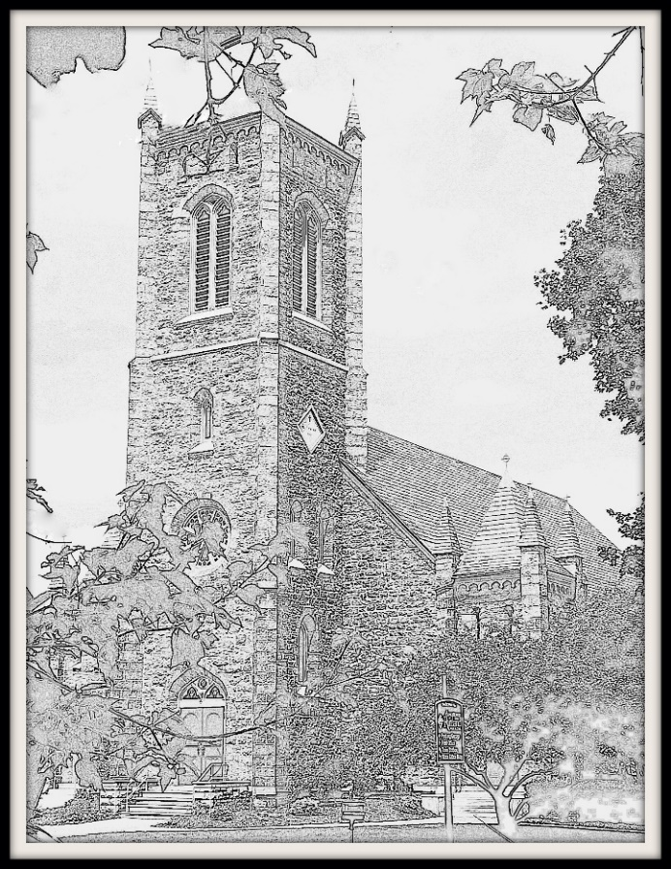

Welcome to our Trinity Church family!

85 West Street, Rutland, VT 05701

(802) 775-4368

office@trinitychurchrutland.org

www.trinitychurchrutland.org

We are a dynamic Episcopal family united in following Christ.

Seeking God Growing in spirituality Serving all with compassion Embracing courageous hope



9:30a.m. Eighth Sunday after Pentecost – Holy Eucharist

The Word of the Lord

**Prelude *Benedictus Alec Rowley***

**Opening Hymn *#411 O bless the Lord, my soul***

Opening Sentences

Celebrant: Blessed be the one, holy, and living God.

*People: Glory to God for ever and ever.*

Celebrant: Holy Wisdom, in your loving kindness you created and restored us when we were lost: inspire us with your truth, that we may love you with our whole minds and run to you with open hearts, through Christ our Savior. *Amen.*

**Gloria in Excelsis *S 277***

The Collect of the Day

Celebrant: God is with you.

*People: And also with you.*

Celebrant: Let us pray.

Let your continual mercy, O Lord, cleanse and defend your Church; and, because it cannot continue in safety without your help, protect and govern it always by your goodness; through Jesus Christ our Lord, who lives and reigns with you and the Holy Spirit, one God, for ever and ever. *Amen*.

Lessons of the Day

First Reading Ecclesiastes 1:2, 12-14; 2:18-23

Reader: A reading from the book of Ecclesiastes.

Vanity of vanities, says the Teacher, vanity of vanities! All is vanity. I, the Teacher, when king over Israel in Jerusalem, applied my mind to seek and to search out by wisdom all that is done under heaven; it is an unhappy business that God has given to human beings to be busy with. I saw all the deeds that are done under the sun; and see, all is vanity and a chasing after wind. I hated all my toil in which I had toiled under the sun, seeing that I must leave it to those who come after me -- and who knows whether they will be wise or foolish? Yet they will be master of all for which I toiled and used my wisdom under the sun. This also is vanity. So I turned and gave my heart up to despair concerning all the toil of my labors under the sun, because sometimes one who has toiled with wisdom and knowledge and skill must leave all to be enjoyed by another who did not toil for it. This also is vanity and a great evil. What do mortals get from all the toil and strain with which they toil under the sun? For all their days are full of pain, and their work is a vexation; even at night their minds do not rest. This also is vanity.

Hear what the Spirit is saying to God’s people.

*People: Thanks be to God.*

Psalm Psalm 49:1-11

Priest: Please join me in reciting Psalm 49. The congregation will respond on the italicized verses.

1 Hear this, all you peoples; hearken, all you who dwell in the world, *

you of high degree and low, rich and poor together.

*2 My mouth shall speak of wisdom, \**

*and my heart shall meditate on understanding.*

3 I will incline my ear to a proverb *

and set forth my riddle upon the harp.

*4 Why should I be afraid in evil days, \**

*when the wickedness of those at my heels surrounds me,*

5 The wickedness of those who put their trust in their goods, *

and boast of their great riches?

*6 We can never ransom ourselves, \**

*or deliver to God the price of our life;*

7 For the ransom of our life is so great, *

that we should never have enough to pay it,

*8 In order to live for ever and ever, \**

*and never see the grave.*

9 For we see that the wise die also; like the dull and stupid they perish *

and leave their wealth to those who come after them.

*10 Their graves shall be their homes for ever,*

*their dwelling places from generation to generation, \**

*though they call the lands after their own names.*

11 Even though honored, they cannot live for ever; *

they are like the beasts that perish.

Second Reading Colossians 3:1-11

Reader: A reading from the letter to the Colossians.

If you have been raised with Christ, seek the things that are above, where Christ is, seated at the right hand of God. Set your minds on things that are above, not on things that are on earth, for you have died, and your life is hidden with Christ in God. When Christ who is your life is revealed, then you also will be revealed with him in glory. Put to death, therefore, whatever in you is earthly: fornication, impurity, passion, evil desire, and greed (which is idolatry). On account of these the wrath of God is coming on those who are disobedient. These are the ways you also once followed, when you were living that life. But now you must get rid of all such things-- anger, wrath, malice, slander, and abusive language from your mouth. Do not lie to one another, seeing that you have stripped off the old self with its practices and have clothed yourselves with the new self, which is being renewed in knowledge according to the image of its creator. In that renewal there is no longer Greek and Jew, circumcised and uncircumcised, barbarian, Scythian, slave and free; but Christ is all and in all!

Hear what the Spirit is saying to God’s people.

*People: Thanks be to God.*

**Sequence Hymn *#632 O Christ, the Word Incarnate***

Gospel Luke 12:13-21

Celebrant: The Holy Gospel of our Savior Jesus Christ according to Luke.

*People: Glory to you, O Christ.*

Celebrant: Someone in the crowd said to Jesus, "Teacher, tell my brother to divide the family inheritance with me." But he said to him, "Friend, who set me to be a judge or arbitrator over you?" And he said to them, "Take care! Be on your guard against all kinds of greed; for one's life does not consist in the abundance of possessions." Then he told them a parable: "The land of a rich man produced abundantly. And he thought to himself, `What should I do, for I have no place to store my crops?' Then he said, `I will do this: I will pull down my barns and build larger ones, and there I will store all my grain and my goods. And I will say to my soul, `Soul, you have ample goods laid up for many years; relax, eat, drink, be merry.' But God said to him, `You fool! This very night your life is being demanded of you. And the things you have prepared, whose will they be?' So it is with those who store up treasures for themselves but are not rich toward God."

The Gospel of Christ.

*People: Praise to you, O Christ.*

Report on General Convention / Homily Nanci Gordon / The Rev. Sarah Ginolfi

The Nicene Creed (Congregation)

Officiant: Please join me in saying the Nicene Creed.

*People: We believe in one God, the Father, the Almighty, maker of heaven and earth, of all that is, seen and unseen.*

*We believe in one Lord, Jesus Christ, the only Son of God, eternally begotten of the Father, God from God, Light from Light, true God from true God, begotten, not made, of one Being with the Father. Through him all things were made. For us and for our salvation he came down from heaven: by the power of the Holy Spirit he became incarnate from the Virgin Mary, and was made man. For our sake he was crucified under Pontius Pilate; he suffered death and was buried. On the third day he rose again in accordance with the Scriptures; he ascended into heaven and is seated at the right hand of the Father. He will come again in glory to judge the living and the dead, and his kingdom will have no end.*

*We believe in the Holy Spirit, the Lord, the giver of life, who proceeds from the Father and the Son. With the Father and the Son he is worshiped and glorified. He has spoken through the Prophets. We believe in one holy catholic and apostolic Church. We acknowledge one baptism for the forgiveness of sins. We look for the resurrection of the dead, and the life of the world to come. Amen.*

Intercession Prayers

Reader: Dear God, we seek to follow your will. Guide us as we grow in spirituality, serve all with compassion, and embrace your courageous hope in the world. With all our heart and with all our mind, let us pray to God, saying "God, have mercy."

*Silence.*

Reader: For the peace promised to us by Jesus Christ, for the loving-kindness of God, for the salvation of our souls; for the peace of the world, for the welfare of the Holy Church of God, and for the unity of all peoples; for **The Church of the Province of West Africa; Trinity Church, Shelburne; the Rev. Fred Moser**, let us pray to God.

*People: God, have mercy.*

Reader: For Justin, Archbishop of Canterbury, Michael, our Presiding Bishop, Shannon, our Bishop; and Sarah, our priest, for all bishops and other ministers;

*People: God, have mercy.*

Reader: For our President, for the leaders of the nations, and for all in authority, let us pray to God.

*People: God, have mercy.*

Reader: For the County of Rutland, this city, and for every city and community, and for those who live in them, let us pray to God.

*People: God, have mercy.*

Reader: For seasonable weather, and for an abundance of the fruits of the earth; for this good earth which God has given us, and the wisdom and will to conserve it; for those who travel on land, on water, or in the air, let us pray to God.

*People: God, have mercy.*

Reader: For the aged and infirm, for the widowed and orphans, for the sick and the suffering, and for those commended to our prayers, especially **Samuel & Eli, Nanci, JoAnn & Larry, Jamie, Jerry, Alaine, Patricia**, let us pray to God.

*People: God, have mercy.*

Reader: For the poor and the oppressed, for the unemployed and the destitute, for prisoners and captives, and for all who remember and care for them, let us pray to God.

*People: God, have mercy.*

Reader: For all who have died in the hope of the resurrection, and for all the departed, let us pray to God.

*People: God, have mercy.*

Reader: For deliverance from all danger, violence, oppression, and degradation; that we may end our lives in faith and hope, without suffering and without reproach, let us pray to God.

*People: God, have mercy.*

Reader: For this congregation, let us pray for those celebrating birthdays and anniversaries this week, especially **Jim & Yvonne Panarello, Alden & Keri Franzoni, Patricia Hewitt, Bauer Hill, William Cousineau, Robert Hewitt, Lillian Keough, Brian Billings**. **We especially celebrate the upcoming 60th wedding anniversary of Gary and Elaine Foskett, for whom the altar flowers have been given.** Let us commend ourselves, and one another, and all our life, to Christ our God.

*People: To you, O Lord, our God.*

Celebrant: O God, you made us in your own image and redeemed us through Jesus your Son: Look with compassion on the whole human family; take away the arrogance and hatred which infect our hearts; break down the walls that separate us; unite us in bonds of love; and work through our struggle and confusion to accomplish your purposes on earth; that, in your good time, all nations and races may serve you in harmony around your heavenly throne; through Jesus Christ our Lord. *Amen*.

The Confession and Absolution

Celebrant: Let us confess our sins against God and our neighbor.

*All: Most merciful God, we confess that we have sinned against you in thought, word, and deed, by what we have done, and by what we have left undone. We have not loved you with our whole heart; we have not loved our neighbors as ourselves. We are truly sorry and we humbly repent. For the sake of your Son Jesus Christ, have mercy on us and forgive us; that we may delight in your will, and walk in your ways, to the glory of your Name. Amen.*

Celebrant: Almighty God have mercy on you, forgive you all your sins through our Lord Jesus Christ, strengthen you in all goodness, and by the power of the Holy Spirit keep you in eternal life. *Amen*.

The Peace

Officiant: The peace of Christ be always with you.

*People: And also with you.*

Announcements

*Thank you for your financial commitment to the life of Trinity Church. Your gift helps our church family spread God’s love and joy in the world! (To ensure you receive a giving statement, please ask for offering envelopes or write your name on a plain envelope containing your gift.) Offering plates are located at the top of the center aisle near the altar as well as near the center exit doors.*

The Holy Communion *Enriching Our Worship, Eucharistic Prayer 2*

The Great Thanksgiving

Celebrant: God is with you.

*People: And also with you.*

Celebrant: Lift up your hearts.

*People: We lift them to our God.*

Celebrant: Let us give thanks to the Lord our God.

*People: It is right to give our thanks and praise.*

Celebrant: We praise you and we bless you, holy and gracious God, source of life abundant. From before time you made ready the creation. Your Spirit moved over the deep and brought all things into being: sun, moon, and stars; earth, winds, and waters; and every living thing. You made us in your image, and taught us to walk in your ways. But we rebelled against you, and wandered far away; and yet, as a mother cares for her children, you would not forget us. Time and again you called us to live in the fullness of your love. And so this day we join with Saints and Angels in the chorus of praise that rings through eternity, lifting our voices to magnify you as we say:

Sanctus

*All: Holy, holy, holy Lord, God of power and might.*

*Heaven and earth are full of your glory.*

*Hosanna in the highest.*

*Blessed is the one who comes in the name of the Lord.*

*Hosanna in the highest.*

Eucharistic Prayer

*(Some may kneel during this time. Standing or sitting in reverence are also perfectly acceptable postures.)*

Celebrant: Glory and honor and praise to you, holy and living God. To deliver us from the power of sin and death and to reveal the riches of your grace, you looked with favor upon Mary, your willing servant, that she might conceive and bear a son, Jesus the holy child of God. Living among us, Jesus loved us. He broke bread with outcasts and sinners, healed the sick, and proclaimed good news to the poor. He yearned to draw all the world to himself yet we were heedless of his call to walk in love. Then, the time came for him to complete upon the cross the sacrifice of his life, and to be glorified by you.

On the night before he died for us, Jesus was at table with his friends. He took bread, gave thanks to you, broke it, and gave it to them, and said: “Take, eat: This is my Body, which is given for you. Do this for the remembrance of me.” As supper was ending, Jesus took the cup of wine. Again, he gave thanks to you, gave it to them, and said: “Drink this, all of you: This is my Blood of the new Covenant, which is poured out for you and for all for the forgiveness of sins. Whenever you drink it, do this for the remembrance of me.”

Now gathered at your table, O God of all creation, and remembering Christ, crucified and risen, who was and is and is to come, we offer to you our gifts of bread and wine, and ourselves, a living sacrifice. Pour out your Spirit upon these gifts that they may be the Body and Blood of Christ. Breathe your Spirit over the whole earth and make us your new creation, the Body of Christ given for the world you have made. In the fullness of time bring us, with all your saints, from every tribe and language and people and nation, to feast at the banquet prepared from the foundation of the world. Through Christ and with Christ and in Christ, in the unity of the Holy Spirit, to you be honor, glory, and praise, for ever and ever. AMEN.

The Lord’s Prayer

Celebrant: And now, as our Savior Christ has taught us, we are bold to say,

*All: (Rite I version)*

*Our Father, who art in heaven,*

*hallowed be thy Name,*

*thy kingdom come, thy will be done,*

*on earth as it is in heaven.*

*Give us this day our daily bread.*

*And forgive us our trespasses, as we forgive those who trespass against us.*

*(Rite II version)*

*Our Father in heaven,*

*hallowed be your Name,*

*your kingdom come, your will be done,*

*on earth as in heaven.*

*Give us today our daily bread.*

*Forgive us our sins as we forgive those who sin against us.*

*And lead us not into temptation,*

*but deliver us from evil.*

*For thine is the kingdom,*

*and the power, and the glory,*

*for ever and ever. Amen.*

*Save us from the time of trial,*

*and deliver us from evil.*

*For the kingdom, the power,*

*and the glory are yours,*

*now and for ever. Amen.*

The Fraction

Celebrant: Alleluia! Christ our Passover has sacrificed for us;

*All: Therefore, let us keep the feast. Alleluia!*

The Invitation

Celebrant: The Gifts of God for the People of God. Take them in remembrance that Christ died for you, and feed on him in your hearts by faith, with thanksgiving.

*All are welcome to this table. To receive communion, come up the center aisle and situate along the railing; standing or kneeling. The priest will distribute the bread which may be consumed immediately. The chalice assistant will distribute the wine in portion cups which we will consume altogether back in our pews once we have all received. Alert an usher if you wish to receive communion in your seat. Those wishing to receive a blessing instead of Communion are invited to cross their arms as a signal to the priest. Also, Communion in "one kind" still constitutes the full receipt of Communion. Let those serving Communion know if this is your preference upon arrival to the railing. (There are waste bins at each exit for communion container disposal.)*

Post Communion Prayer

Celebrant: Let us pray.

*All: Loving God, we give you thanks for restoring us in your image and nourishing us with spiritual food in the Sacrament of Christ’s Body and Blood. Now send us forth a people, forgiven, healed, renewed; that we may proclaim your love to the world and continue in the risen life of Christ our Savior. Amen.*

Blessing

Celebrant: God’s Blessing be with you, Christ’s peace be with you, the Spirit’s outpouring be with you, now and always. *Amen*.

**Closing Hymn** ***#344 Lord, dismiss us with thy blessing***

Dismissal

Celebrant: Let us go forth in the name of Christ. Alleluia! Alleluia!

*People: Thanks Be to God!* *Alleluia!* *Alleluia!*

**Postlude *Triumph Song Rowley***

*Exiting: Your presence is a blessing! Thank you for this gift.*