Trinity Church

Tenth Sunday after Pentecost

August 14, 2022

9:30 a.m.

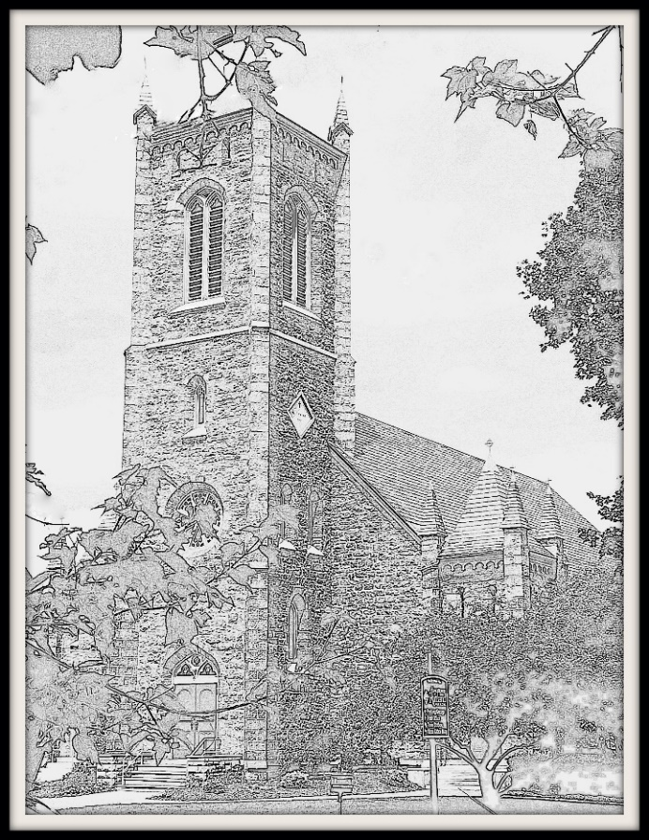

Welcome to our Trinity Church family!

85 West Street, Rutland, VT 05701

(802) 775-4368

office@trinitychurchrutland.org

www.trinitychurchrutland.org

We are a dynamic Episcopal family united in following Christ.

Seeking God Growing in spirituality Serving all with compassion Embracing courageous hope



9:30a.m. Tenth Sunday after Pentecost – Holy Eucharist

The Word of the Lord

**Prelude *Pastorale (Sonata I) Alexandre Guilmant***

**Opening Hymn *#410 Praise, my soul, the King of Heaven***

Opening Sentences

Celebrant: Blessed be the one, holy, and living God.

*People: Glory to God for ever and ever.*

Celebrant: Holy Wisdom, in your loving kindness you created and restored us when we were lost: inspire us with your truth, that we may love you with our whole minds and run to you with open hearts, through Christ our Savior. *Amen.*

**Gloria in Excelsis *S 277***

The Collect of the Day

Celebrant: God is with you.

*People: And also with you.*

Celebrant: Let us pray. Almighty God, you have given your only Son to be for us a sacrifice for sin, and also an example of godly life: Give us grace to receive thankfully the fruits of his redeeming work, and to follow daily in the blessed steps of his most holy life; through Jesus Christ your Son our Lord, who lives and reigns with you and the Holy Spirit, one God, now and for ever. *Amen*.

Lessons of the Day

First Reading Jeremiah 23:23-29

Reader: A reading from the book of Jeremiah.

Am I a God near by, says the Lord, and not a God far off? Who can hide in secret places so that I cannot see them? says the Lord. Do I not fill heaven and earth? says the Lord. I have heard what the prophets have said who prophesy lies in my name, saying, "I have dreamed, I have dreamed!" How long? Will the hearts of the prophets ever turn back-- those who prophesy lies, and who prophesy the deceit of their own heart? They plan to make my people forget my name by their dreams that they tell one another, just as their ancestors forgot my name for Baal. Let the prophet who has a dream tell the dream, but let the one who has my word speak my word faithfully. What has straw in common with wheat? says the Lord. Is not my word like fire, says the Lord, and like a hammer that breaks a rock in pieces?

Hear what the Spirit is saying to God’s people.

*People: Thanks be to God.*

Psalm Psalm 82

Priest: Please join me in reciting Psalm 82. The congregation will respond on the italicized verses.

1 God takes a stand in the council of heaven; *

God gives judgment in the midst of the gods:

*2 "How long will you judge unjustly, \**

*and show favor to the wicked?*

3 Save the weak and the orphan; *

defend the humble and needy;

*4 Rescue the weak and the poor; \**

*deliver them from the power of the wicked.*

5 They do not know, neither do they understand; they go about in darkness; *

all the foundations of the earth are shaken.

*6 Now I say to you, 'You are gods, \**

*and all of you children of the Most High;*

7 Nevertheless, you shall die like mortals, *

and fall like any prince.'"

*8 Arise, O God, and rule the earth, \**

*for you shall take all nations for your own.*

Second Reading Hebrews 11:29-12:2

Reader: A reading from the letter to the Hebrews.

By faith the people passed through the Red Sea as if it were dry land, but when the Egyptians attempted to do so they were drowned. By faith the walls of Jericho fell after they had been encircled for seven days. By faith Rahab the prostitute did not perish with those who were disobedient, because she had received the spies in peace. And what more should I say? For time would fail me to tell of Gideon, Barak, Samson, Jephthah, of David and Samuel and the prophets-- who through faith conquered kingdoms, administered justice, obtained promises, shut the mouths of lions, quenched raging fire, escaped the edge of the sword, won strength out of weakness, became mighty in war, put foreign armies to flight. Women received their dead by resurrection. Others were tortured, refusing to accept release, in order to obtain a better resurrection. Others suffered mocking and flogging, and even chains and imprisonment. They were stoned to death, they were sawn in two, they were killed by the sword; they went about in skins of sheep and goats, destitute, persecuted, tormented-- of whom the world was not worthy. They wandered in deserts and mountains, and in caves and holes in the ground. Yet all these, though they were commended for their faith, did not receive what was promised, since God had provided something better so that they would not, apart from us, be made perfect. Therefore, since we are surrounded by so great a cloud of witnesses, let us also lay aside every weight and the sin that clings so closely, and let us run with perseverance the race that is set before us, looking to Jesus the pioneer and perfecter of our faith, who for the sake of the joy that was set before him endured the cross, disregarding its shame, and has taken his seat at the right hand of the throne of God.

Hear what the Spirit is saying to God’s people.

*People: Thanks be to God.*

**Sequence Hymn *#467 Sing, my soul, his wondrous love***

Gospel Luke 12:49-56

Celebrant: The Holy Gospel of our Savior Jesus Christ according to Luke.

*People: Glory to you, O Christ.*

Celebrant: Jesus said, "I came to bring fire to the earth, and how I wish it were already kindled! I have a baptism with which to be baptized, and what stress I am under until it is completed! Do you think that I have come to bring peace to the earth? No, I tell you, but rather division! From now on five in one household will be divided, three against two and two against three; they will be divided: father against son and son against father, mother against daughter and daughter against mother, mother-in-law against her daughter-in-law and daughter-in-law against mother-in-law." He also said to the crowds, "When you see a cloud rising in the west, you immediately say, `It is going to rain'; and so it happens. And when you see the south wind blowing, you say, `There will be scorching heat'; and it happens. You hypocrites! You know how to interpret the appearance of earth and sky, but why do you not know how to interpret the present time?"

The Gospel of Christ.

*People: Praise to you, O Christ.*

Sermon The Rev. Rachel Field

The Nicene Creed (Congregation)

Officiant: Please join me in saying the Nicene Creed.

*People: We believe in one God, the Father, the Almighty, maker of heaven and earth, of all that is, seen and unseen.*

*We believe in one Lord, Jesus Christ, the only Son of God, eternally begotten of the Father, God from God, Light from Light, true God from true God, begotten, not made, of one Being with the Father. Through him all things were made. For us and for our salvation he came down from heaven: by the power of the Holy Spirit he became incarnate from the Virgin Mary, and was made man. For our sake he was crucified under Pontius Pilate; he suffered death and was buried. On the third day he rose again in accordance with the Scriptures; he ascended into heaven and is seated at the right hand of the Father. He will come again in glory to judge the living and the dead, and his kingdom will have no end.*

*We believe in the Holy Spirit, the Lord, the giver of life, who proceeds from the Father and the Son. With the Father and the Son he is worshiped and glorified. He has spoken through the Prophets. We believe in one holy catholic and apostolic Church. We acknowledge one baptism for the forgiveness of sins. We look for the resurrection of the dead, and the life of the world to come. Amen.*

Intercession Prayers

Reader: Dear God, we seek to follow your will. Guide us as we grow in spirituality, serve all with compassion, and embrace your courageous hope in the world. In peace, we pray to you, O God.

*Silence.*

Reader: For all people in their daily life and work;

*People: For our families, friends, and neighbors, and for those who are alone.*

Reader: For this community, the nation, and the world;

*People: For all who work for justice, freedom, and peace.*

Reader: For the just and proper use of your creation;

*People: For the victims of hunger, fear, injustice, and oppression.*

Reader: For all who are in danger, sorrow, or any kind of trouble;

*People: For those who minister to the sick, the friendless, and the needy.*

Reader: For the peace and unity of the Church of God. In our cycle of prayers, we pray for **The Extra-Provincial Churches; All Saints Church, South Burlington; the Rev. David Hamilton, Deacon Peggy Mathauer.**

*People: For all who proclaim the Gospel, and all who seek the Truth.*

Reader: For Justin, Archbishop of Canterbury, Michael, our Presiding Bishop, Shannon, our Bishop; and Sarah, our priest, **and for Rachel who celebrates with us today,** for all bishops and other ministers;

*People: For all who serve God in his Church.*

Reader: For the special needs and concerns of this congregation. We pray especially for: **Jamie**.

*Silence to allow for private petitions.*

Reader: Hear us, O God;

*People: For your mercy is great.*

Reader: We thank you, O God, for all the blessings of this life. We pray especially for those parishioners celebrating birthdays and anniversaries: **Jamie Stacy & Holly Webb, Katya Cooke & Randall Smathers, Alexis Muscatello, Kayla Trombley, Shelly Susina, Marie Scott.** We will exalt you, O God our King;

*People: And praise your Name for ever and ever.*

Reader: We pray for all who have died, **especially Leone and William Fryer, and Patricia and Alfred Peterson for whom the altar flowers have been given**, that they may have a place in your eternal kingdom. O God, let your loving-kindness be upon them;

*People: Who put their trust in you.*

Celebrant: Almighty and everlasting God, you made the universe with all its marvelous order, its atoms, worlds, and galaxies, and the infinite complexity of living creatures: Grant that, as we probe the mysteries of your creation, we may come to know you more truly, and more surely fulfill our role in your eternal purpose; in the name of Jesus Christ our Lord. *Amen*.

The Confession and Absolution

Celebrant: Let us confess our sins against God and our neighbor.

*All: Most merciful God, we confess that we have sinned against you in thought, word, and deed, by what we have done, and by what we have left undone. We have not loved you with our whole heart; we have not loved our neighbors as ourselves. We are truly sorry and we humbly repent. For the sake of your Son Jesus Christ, have mercy on us and forgive us; that we may delight in your will, and walk in your ways, to the glory of your Name. Amen.*

Celebrant: Almighty God have mercy on you, forgive you all your sins through our Lord Jesus Christ, strengthen you in all goodness, and by the power of the Holy Spirit keep you in eternal life. *Amen*.

The Peace

Officiant: The peace of Christ be always with you.

*People: And also with you.*

Announcements

*Thank you for your financial commitment to the life of Trinity Church. Your gift helps our church family spread God’s love and joy in the world! (To ensure you receive a giving statement, please ask for offering envelopes or write your name on a plain envelope containing your gift.) Offering plates are located at the top of the center aisle near the altar as well as near the center exit doors.*

The Holy Communion *Enriching Our Worship, Eucharistic Prayer 2*

The Great Thanksgiving

Celebrant: God is with you.

*People: And also with you.*

Celebrant: Lift up your hearts.

*People: We lift them to our God.*

Celebrant: Let us give thanks to the Lord our God.

*People: It is right to give our thanks and praise.*

Celebrant: We praise you and we bless you, holy and gracious God, source of life abundant. From before time you made ready the creation. Your Spirit moved over the deep and brought all things into being: sun, moon, and stars; earth, winds, and waters; and every living thing. You made us in your image, and taught us to walk in your ways. But we rebelled against you, and wandered far away; and yet, as a mother cares for her children, you would not forget us. Time and again you called us to live in the fullness of your love. And so this day we join with Saints and Angels in the chorus of praise that rings through eternity, lifting our voices to magnify you as we say:

Sanctus

*All: Holy, holy, holy Lord, God of power and might.*

*Heaven and earth are full of your glory.*

*Hosanna in the highest.*

*Blessed is the one who comes in the name of the Lord.*

*Hosanna in the highest.*

Eucharistic Prayer

*(Some may kneel during this time. Standing or sitting in reverence are also perfectly acceptable postures.)*

Celebrant: Glory and honor and praise to you, holy and living God. To deliver us from the power of sin and death and to reveal the riches of your grace, you looked with favor upon Mary, your willing servant, that she might conceive and bear a son, Jesus the holy child of God. Living among us, Jesus loved us. He broke bread with outcasts and sinners, healed the sick, and proclaimed good news to the poor. He yearned to draw all the world to himself yet we were heedless of his call to walk in love. Then, the time came for him to complete upon the cross the sacrifice of his life, and to be glorified by you.

On the night before he died for us, Jesus was at table with his friends. He took bread, gave thanks to you, broke it, and gave it to them, and said: “Take, eat: This is my Body, which is given for you. Do this for the remembrance of me.” As supper was ending, Jesus took the cup of wine. Again, he gave thanks to you, gave it to them, and said: “Drink this, all of you: This is my Blood of the new Covenant, which is poured out for you and for all for the forgiveness of sins. Whenever you drink it, do this for the remembrance of me.”

Now gathered at your table, O God of all creation, and remembering Christ, crucified and risen, who was and is and is to come, we offer to you our gifts of bread and wine, and ourselves, a living sacrifice. Pour out your Spirit upon these gifts that they may be the Body and Blood of Christ. Breathe your Spirit over the whole earth and make us your new creation, the Body of Christ given for the world you have made. In the fullness of time bring us, with all your saints, from every tribe and language and people and nation, to feast at the banquet prepared from the foundation of the world. Through Christ and with Christ and in Christ, in the unity of the Holy Spirit, to you be honor, glory, and praise, for ever and ever. AMEN.

The Lord’s Prayer

Celebrant: And now, as our Savior Christ has taught us, we are bold to say,

*All: (Rite I version)*

*Our Father, who art in heaven, hallowed be thy Name,*

*thy kingdom come, thy will be done, on earth as it is in heaven.*

*Give us this day our daily bread.*

*And forgive us our trespasses, as we forgive those who trespass against us.*

*And lead us not into temptation, but deliver us from evil.*

*For thine is the kingdom, and the power, and the glory, for ever and ever. Amen.*

*(Rite II version)*

*Our Father in heaven,*

*hallowed be your Name,*

*your kingdom come, your will be done, on earth as in heaven.*

*Give us today our daily bread.*

*Forgive us our sins as we forgive those*

*who sin against us.*

*Save us from the time of trial,*

*and deliver us from evil.*

*For the kingdom, the power, and the glory are yours, now and for ever.*

*Amen.*

The Fraction

Celebrant: Alleluia! Christ our Passover has sacrificed for us;

*All: Therefore, let us keep the feast. Alleluia!*

The Invitation

Celebrant: The Gifts of God for the People of God. Take them in remembrance that Christ died for you, and feed on him in your hearts by faith, with thanksgiving.

*All are welcome to this table. To receive communion, come up the center aisle and situate along the railing; standing or kneeling. The priest will distribute the bread which may be consumed immediately. The chalice assistant will distribute the wine in portion cups which we will consume altogether back in our pews once we have all received. Alert an usher if you wish to receive communion in your seat. Those wishing to receive a blessing instead of Communion are invited to cross their arms as a signal to the priest. Also, Communion in "one kind" still constitutes the full receipt of Communion. Let those serving Communion know if this is your preference upon arrival to the railing. (There are waste bins at each exit for communion container disposal.)*

Post Communion Prayer

Celebrant: Let us pray.

*All: Loving God, we give you thanks for restoring us in your image and nourishing us with spiritual food in the Sacrament of Christ’s Body and Blood. Now send us forth a people, forgiven, healed, renewed; that we may proclaim your love to the world and continue in the risen life of Christ our Savior. Amen.*

Blessing

Celebrant: The Wisdom of God, the Love of God, and the Grace of God strengthen you to be Christ’s hands and heart in this world, in the name of the Holy Trinity. *Amen*.

**Closing Hymn** ***#341 For the bread which you have broken***

Dismissal

Celebrant: Let us go forth in the name of Christ. Alleluia! Alleluia!

*People: Thanks Be to God!* *Alleluia!* *Alleluia!*

**Postlude *Grand Choeur Guilmant***

*Exiting: Your presence is a blessing! Thank you for this gift.*